

**ASSIGNMENT -2**

**COURSE: DevOps Name: K. MONIKA**

**MODULE: Transit Gateway Gmail: monikakudithetti@gmail.com**

**TRAINER: Mr. Madhukar sir Batch no: 120 - 5pm**

**Date: 01-03-2024**

**1. Creation of Transit Gateway in two different accounts.**

**Step 1:** Create a VPC account in Virginia region in an account. Give any name for the VPC along with any CIDR value available.

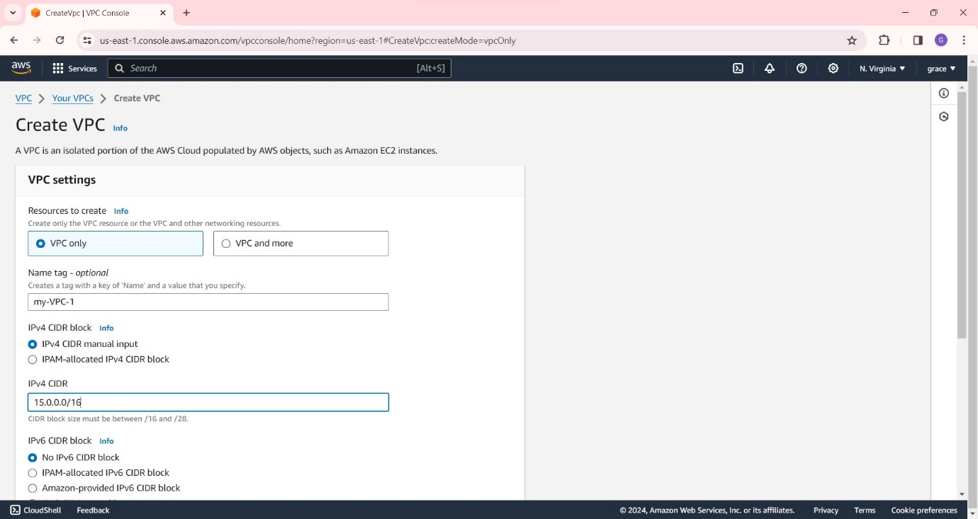

**Step 2:** Create a subnet for this VPC with any name.

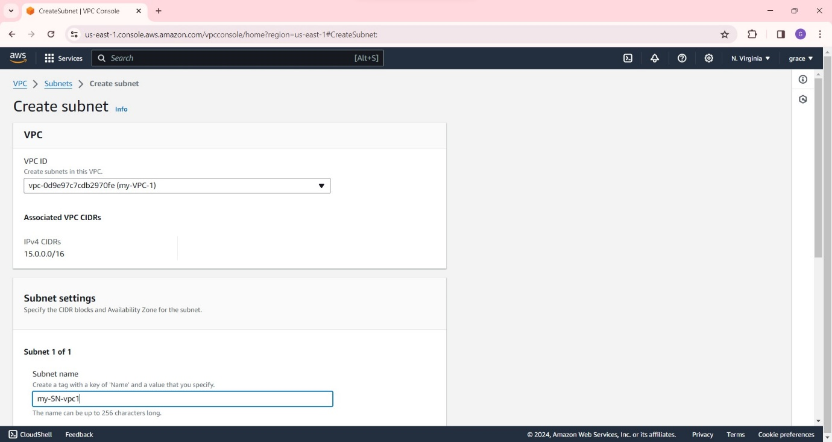

**Step 3:** Now create Internet Gateway to the VPC.

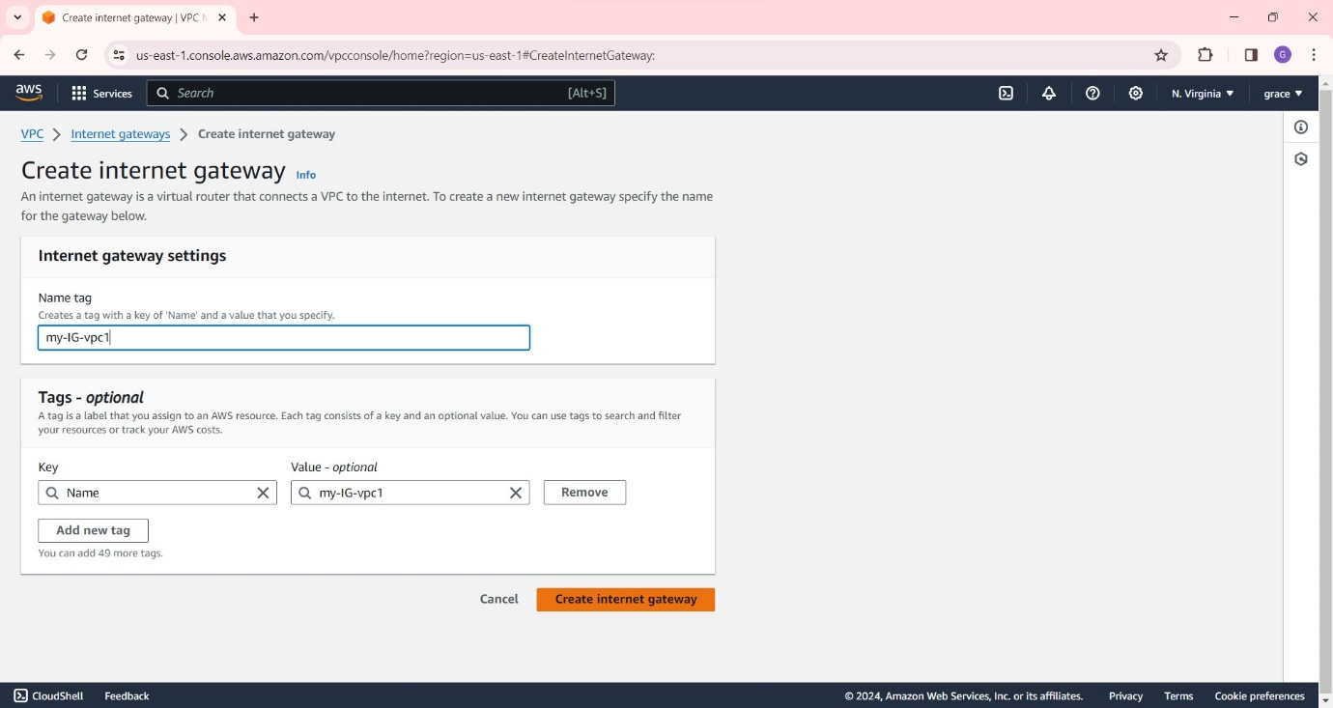

**Step 4:** Attach this Internet Gateway to the VPC as below.

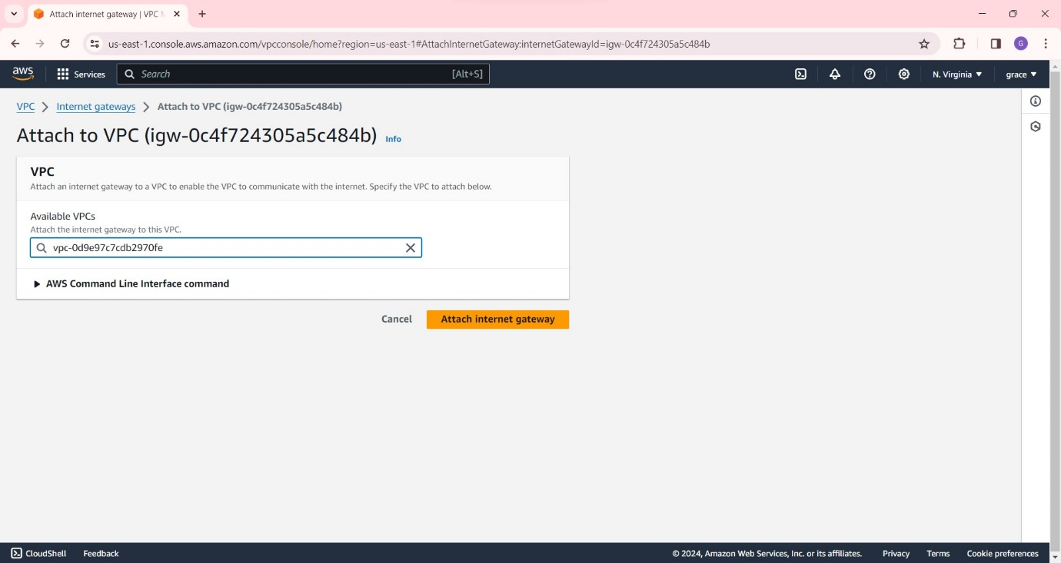

**Step 5:** Go to route tables and create a route table with any name and select its respective VPC ID.

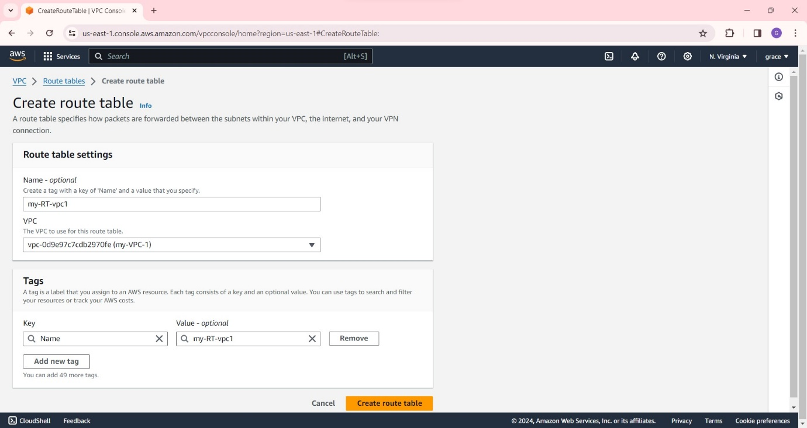

**Step 6:** Now go to ‘Subnet Associations’ below and click on edit and select its respective Subnet as shown below.

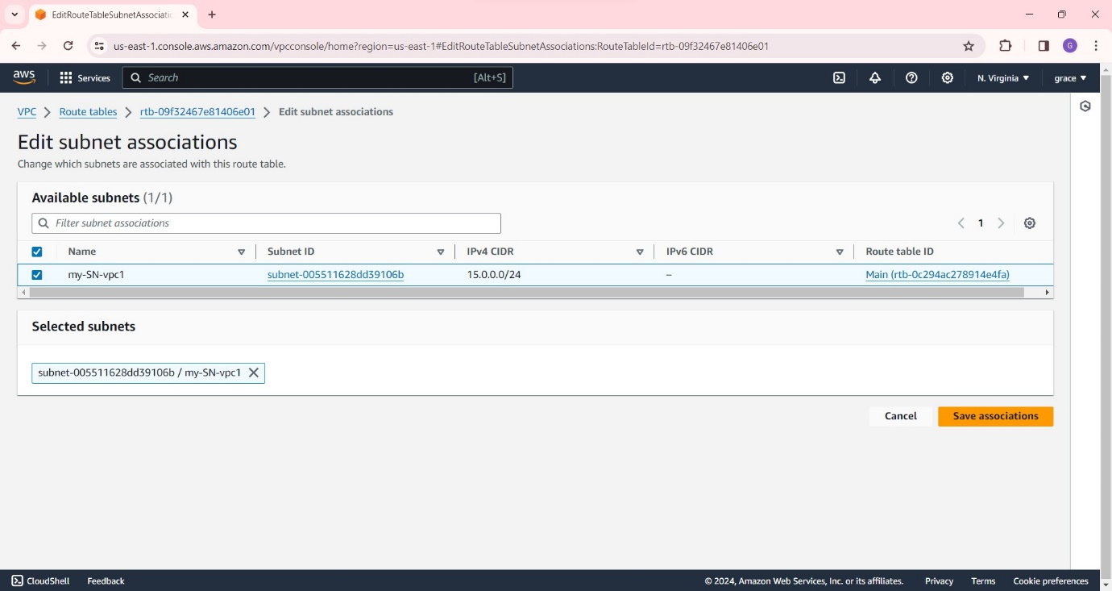

**Step 7:** Now go to the same route table and click on ‘edit routes’ add the route and click on internet gateway in the following manner.

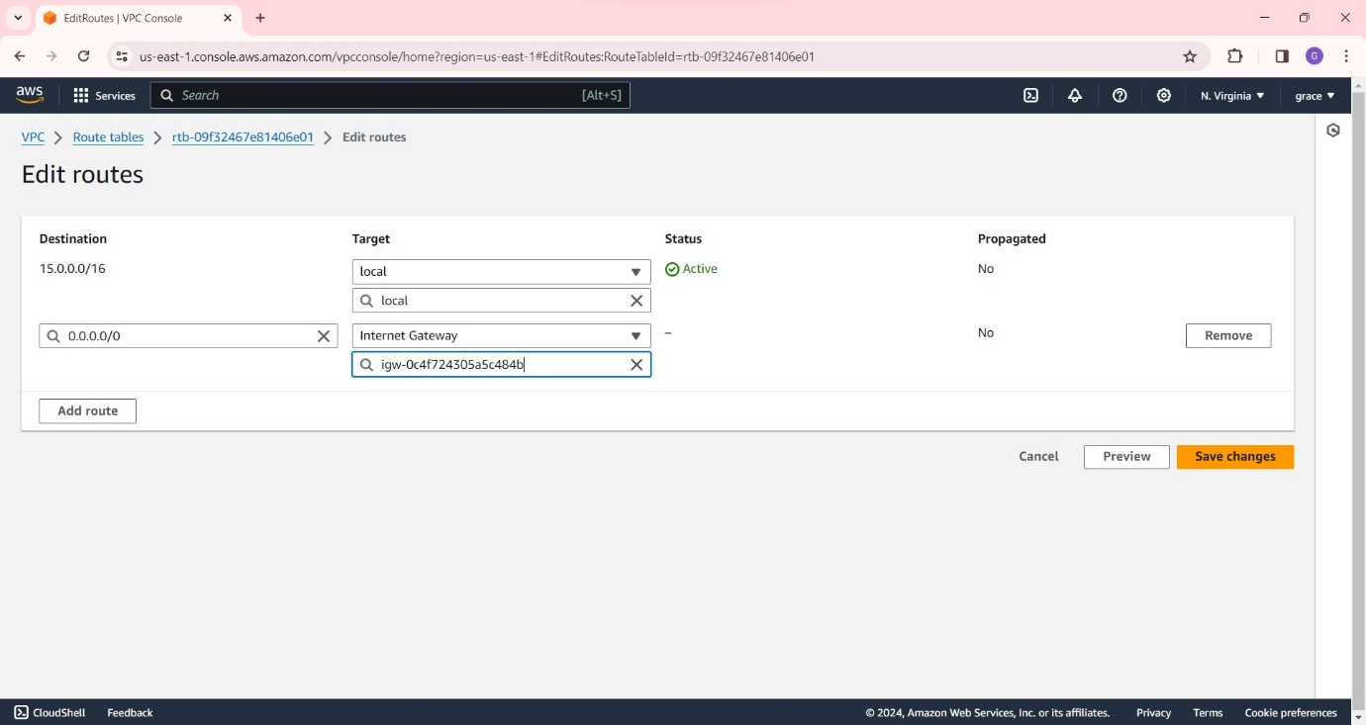

**Step 8**: Similarly , repeat all the steps in the another AWS account as the following:

1. create VPC

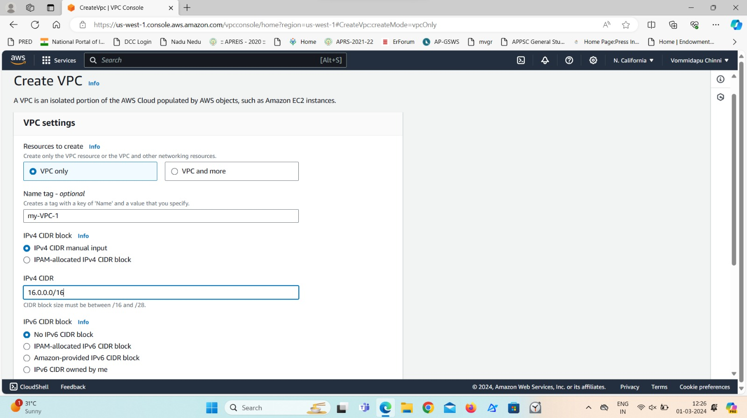

1. Create a subnet

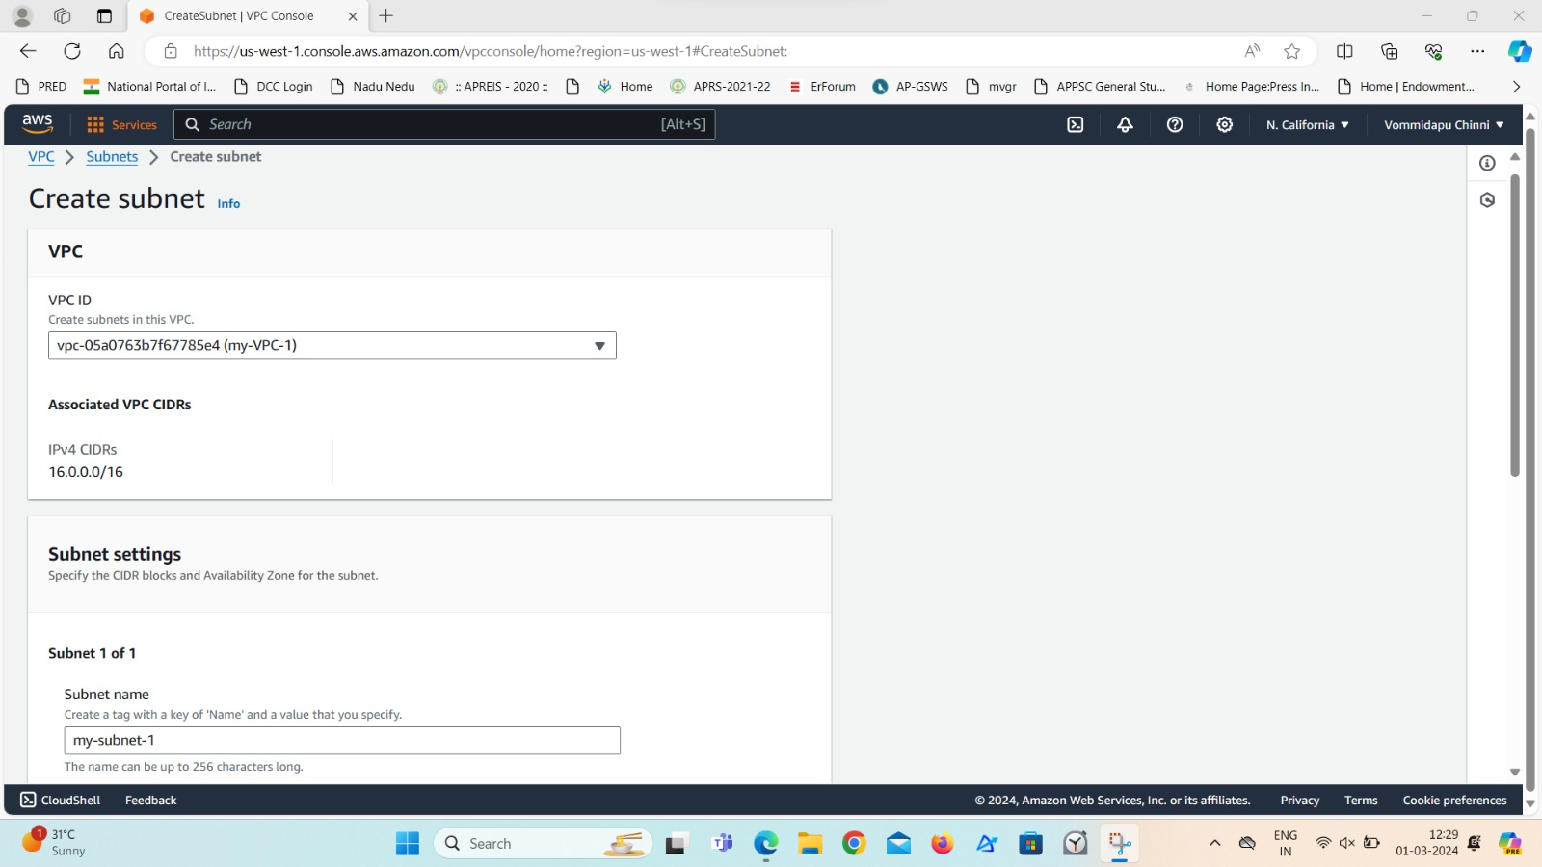

1. Create Internet Gateway.

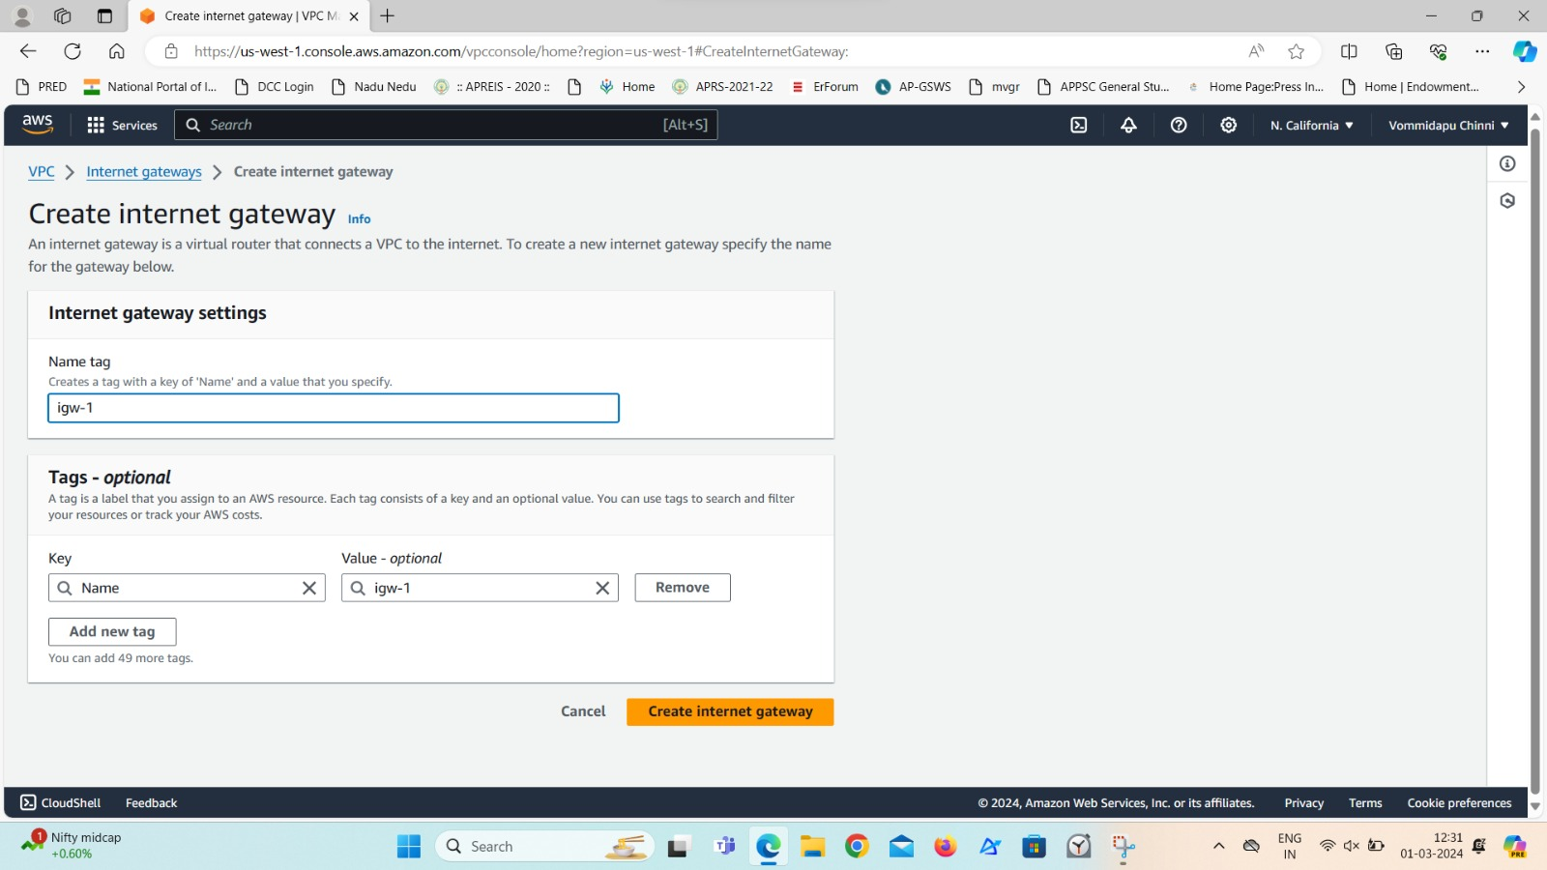

1. Attach VPC to it.

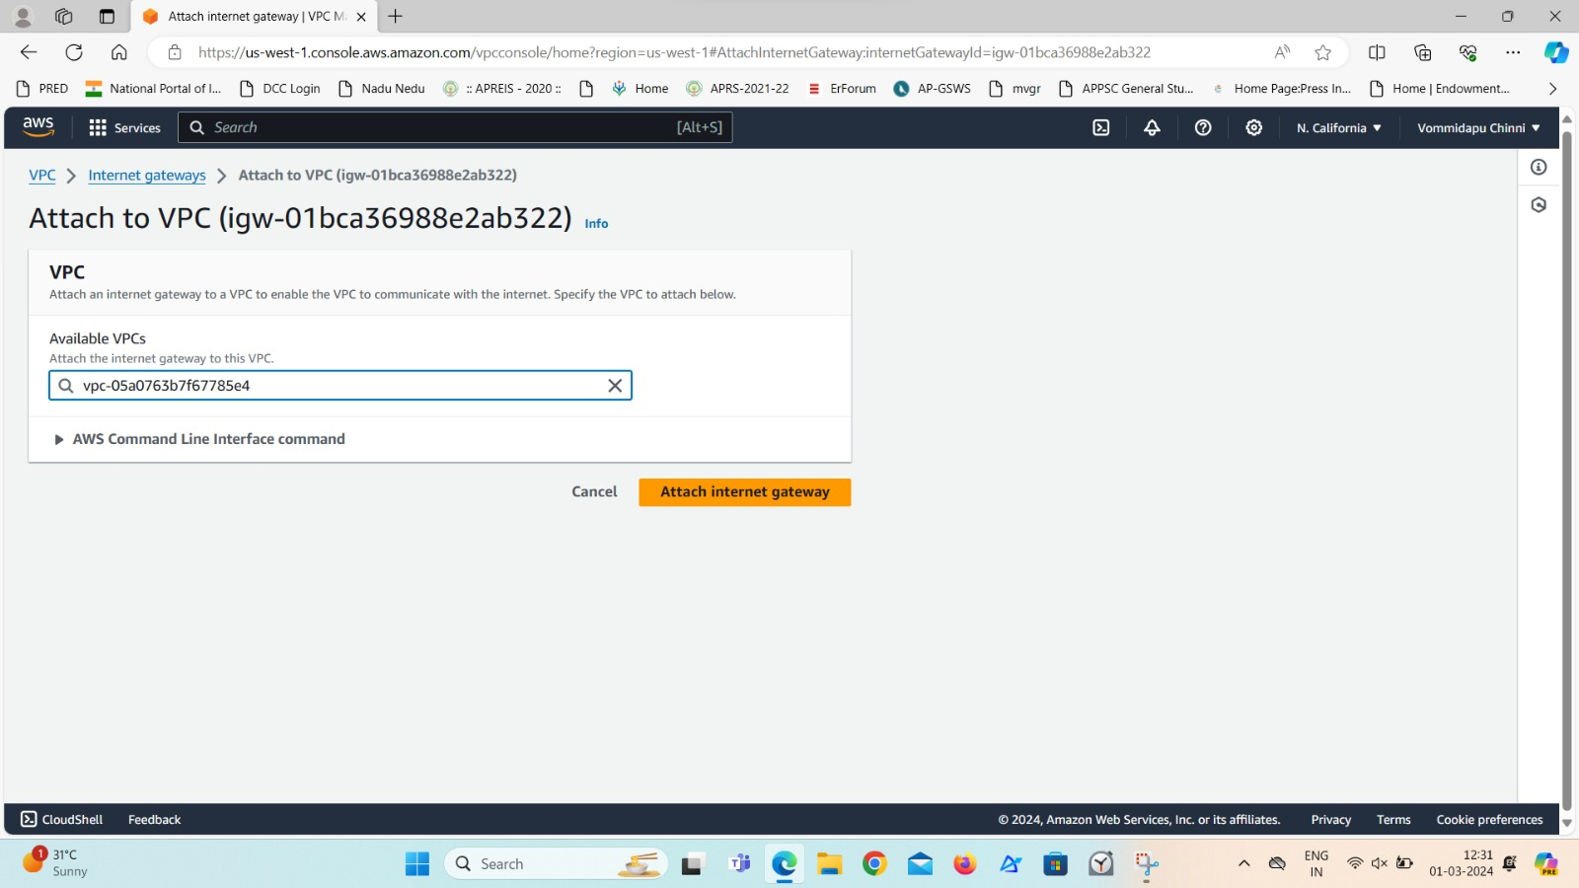

1. Create Route Table and edit the routes.

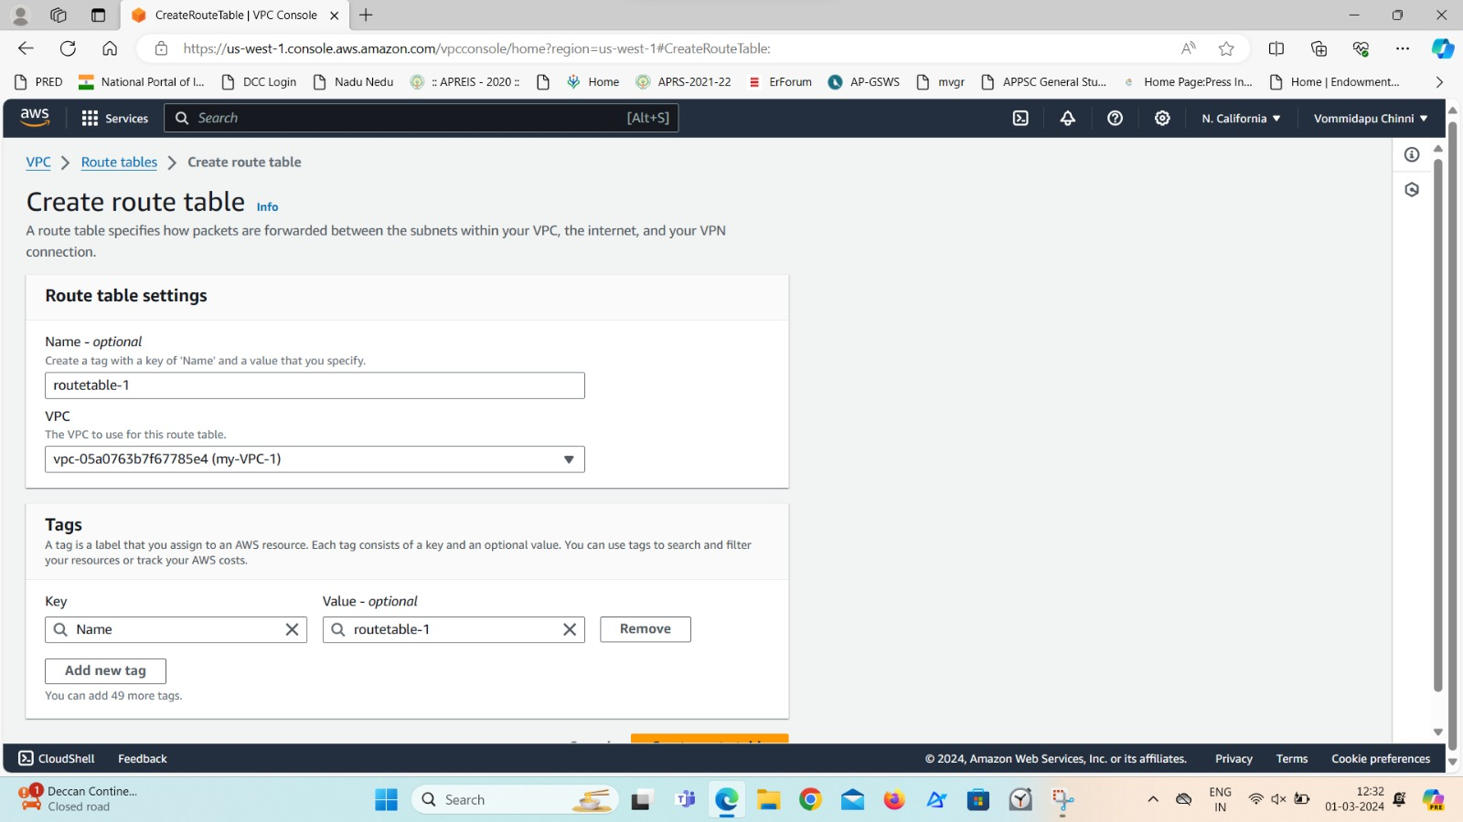

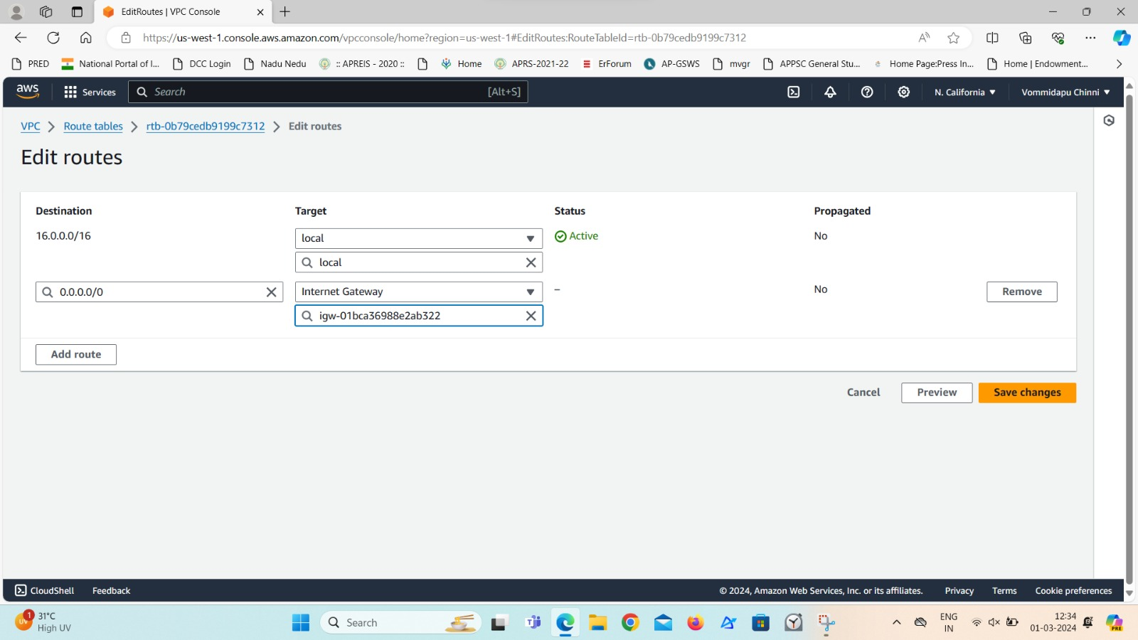

1. Add subnet association to the route table.

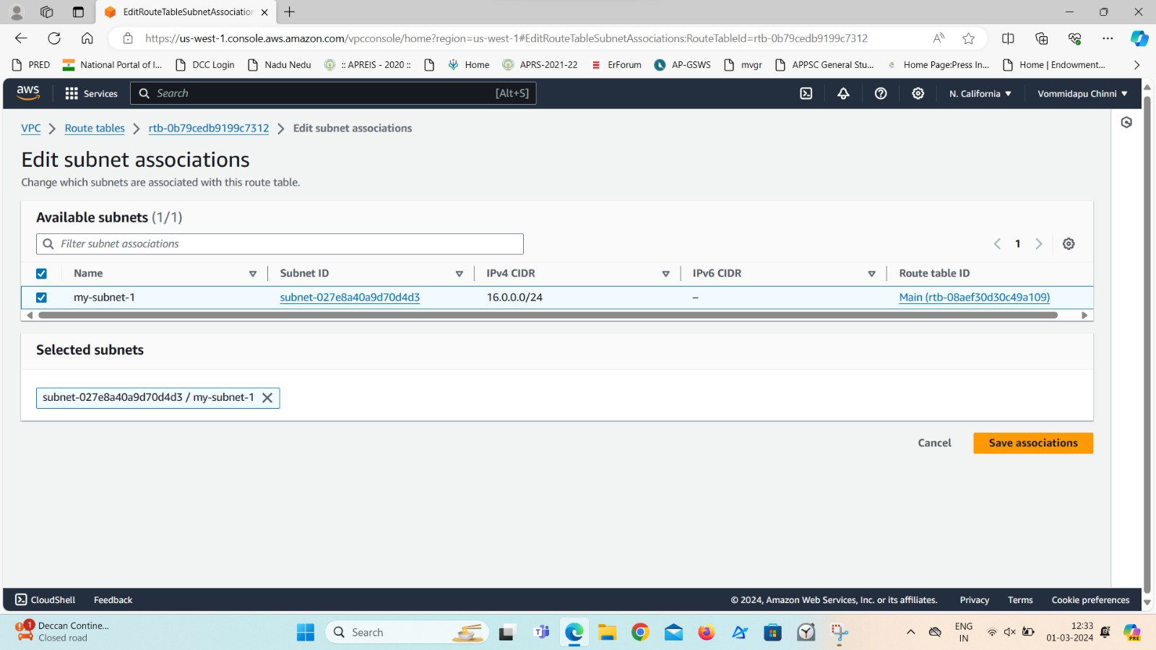

**Step 9:** Now come back to the first AWS account and create Transit Gateway.

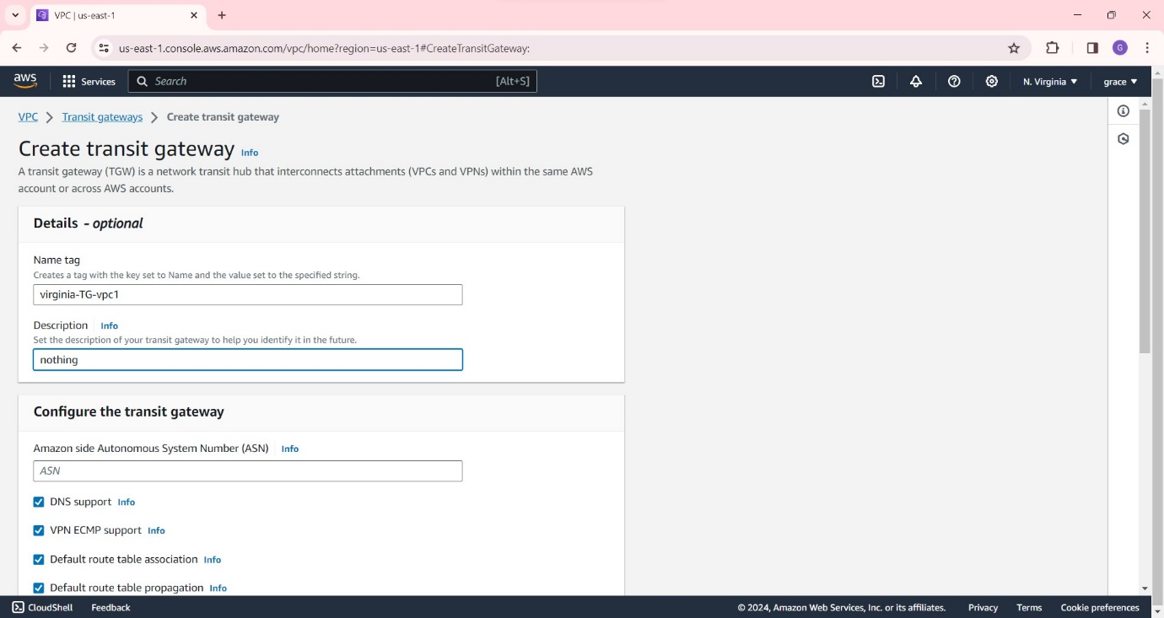

Give any name to the transit gateway with any description and click on create Transit Gateway.

**Step 10:** Go to Transit Gtateway Attachments and select our transit gateway ID.Select the attachment type as VPC.

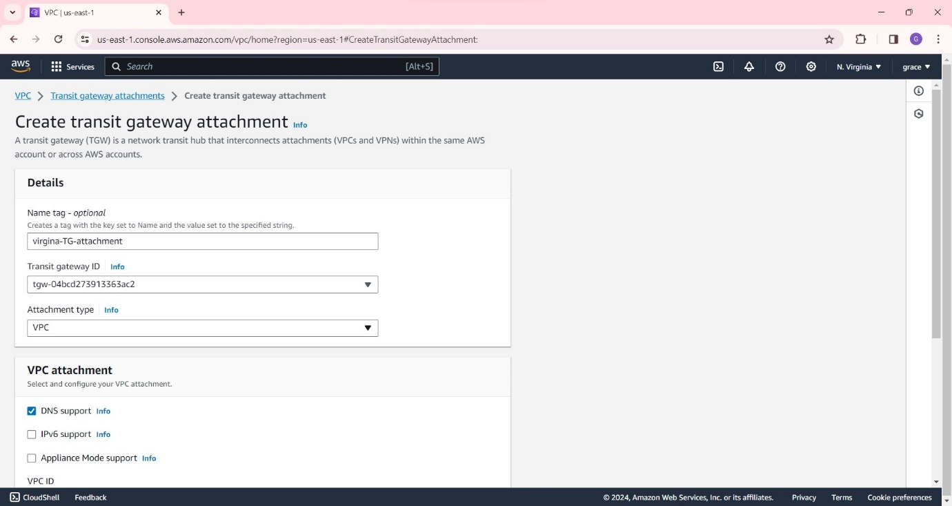

Also, select the VPC ID with its subnet and click on create transit gateway attachment.

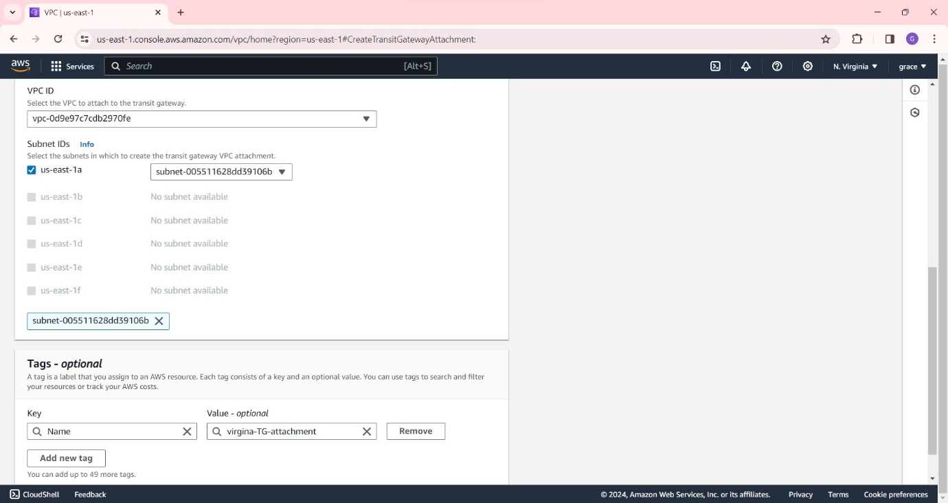

**Step 11:** Now Edit the routes.

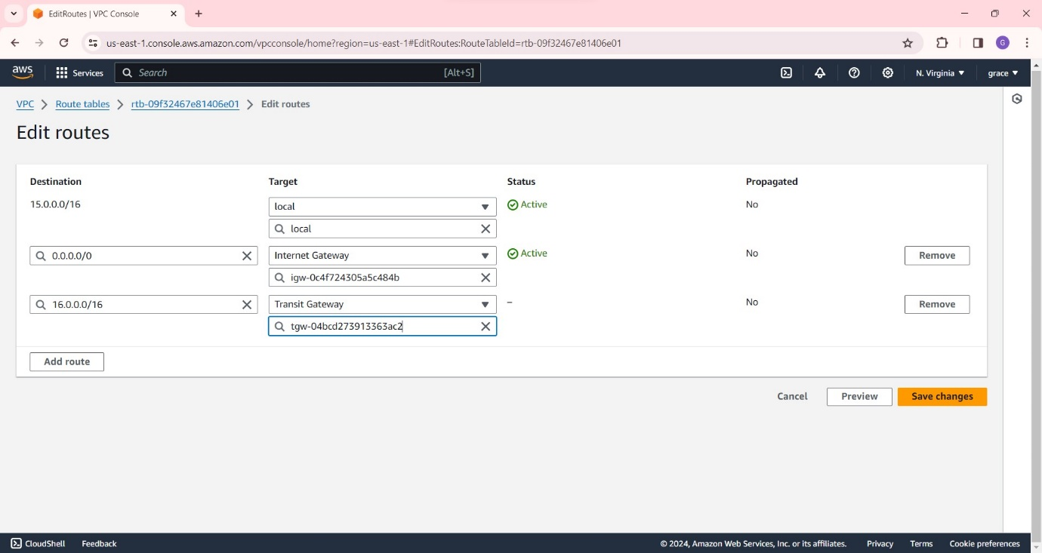

**Step 12:** Similarly create transit gateway in another account.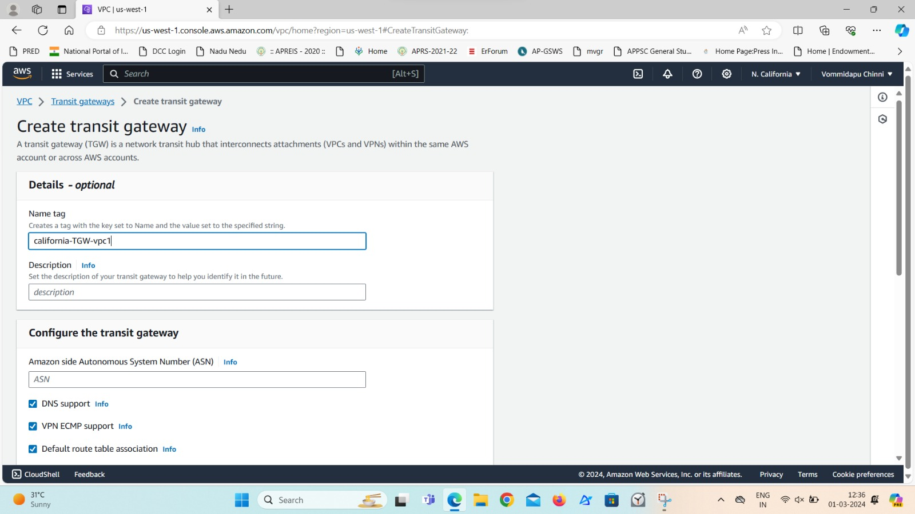

After this, edit the routes as follows.

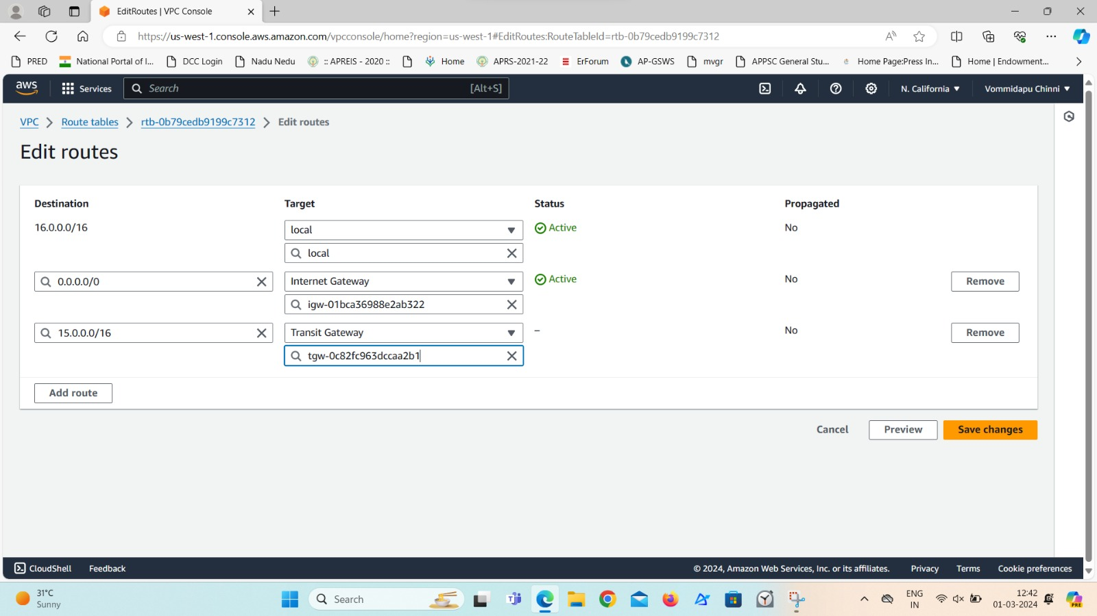

**Step 13:** Now go to first account and create another transit gateway attachment to do peering between the two accounts , to transfer the data between them.

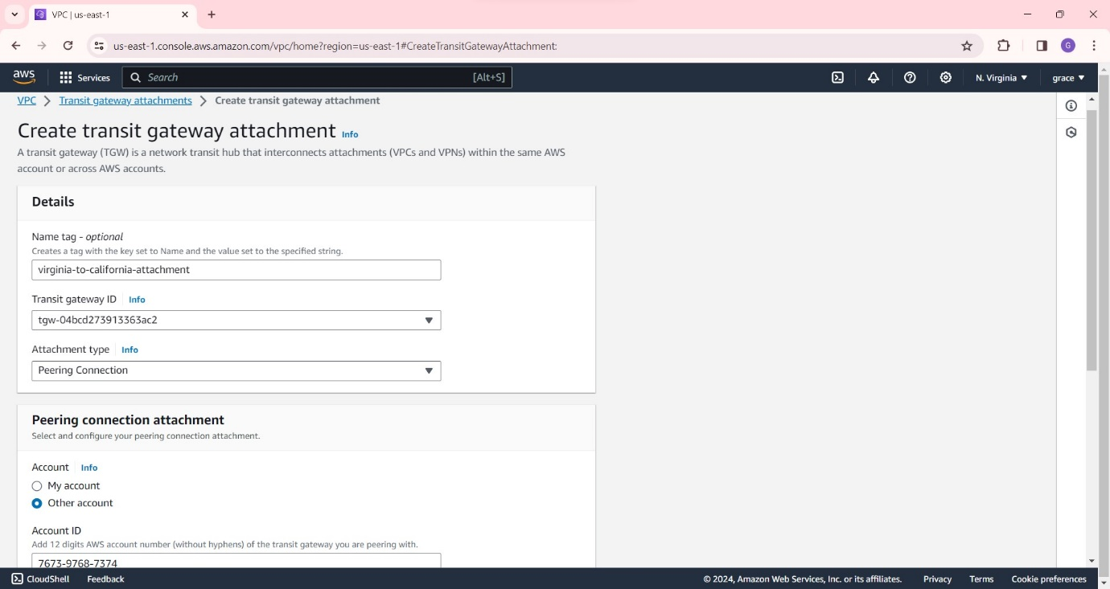

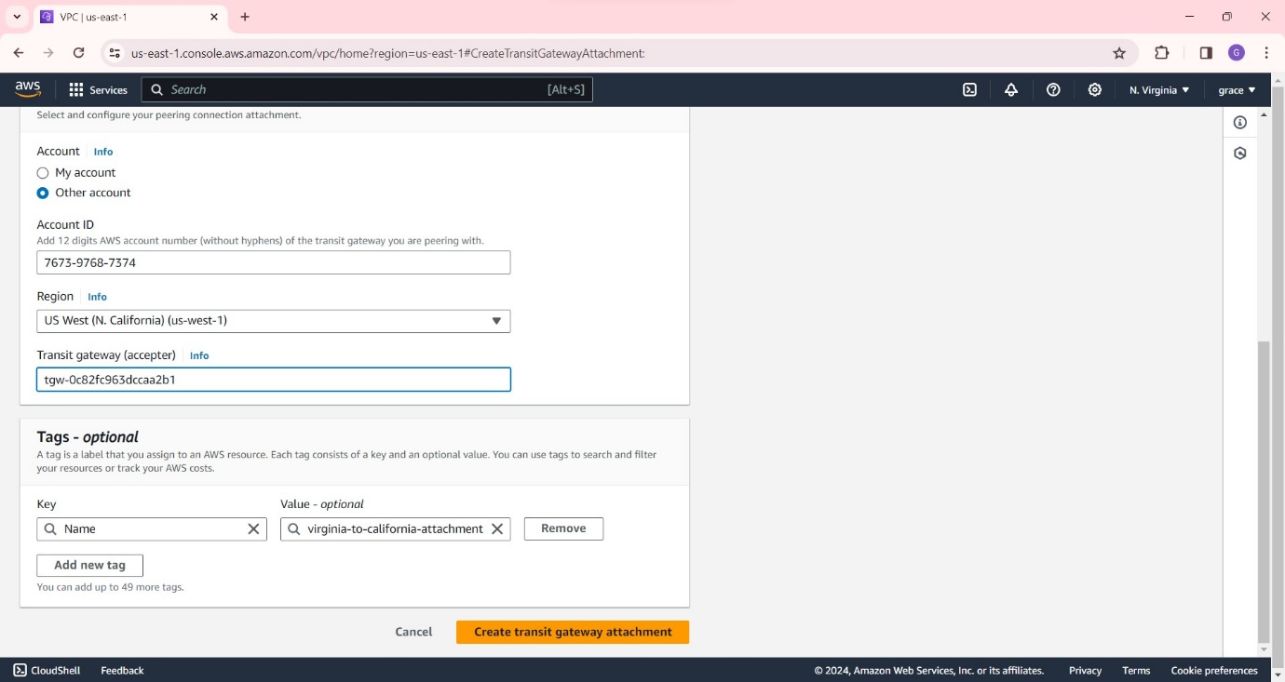

**Step 14:** Now send the request from Virginia account to California account.

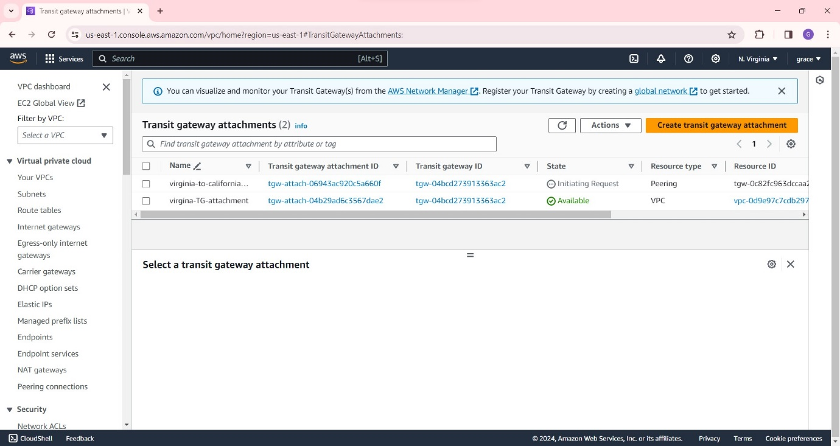

And then accept the request at California.

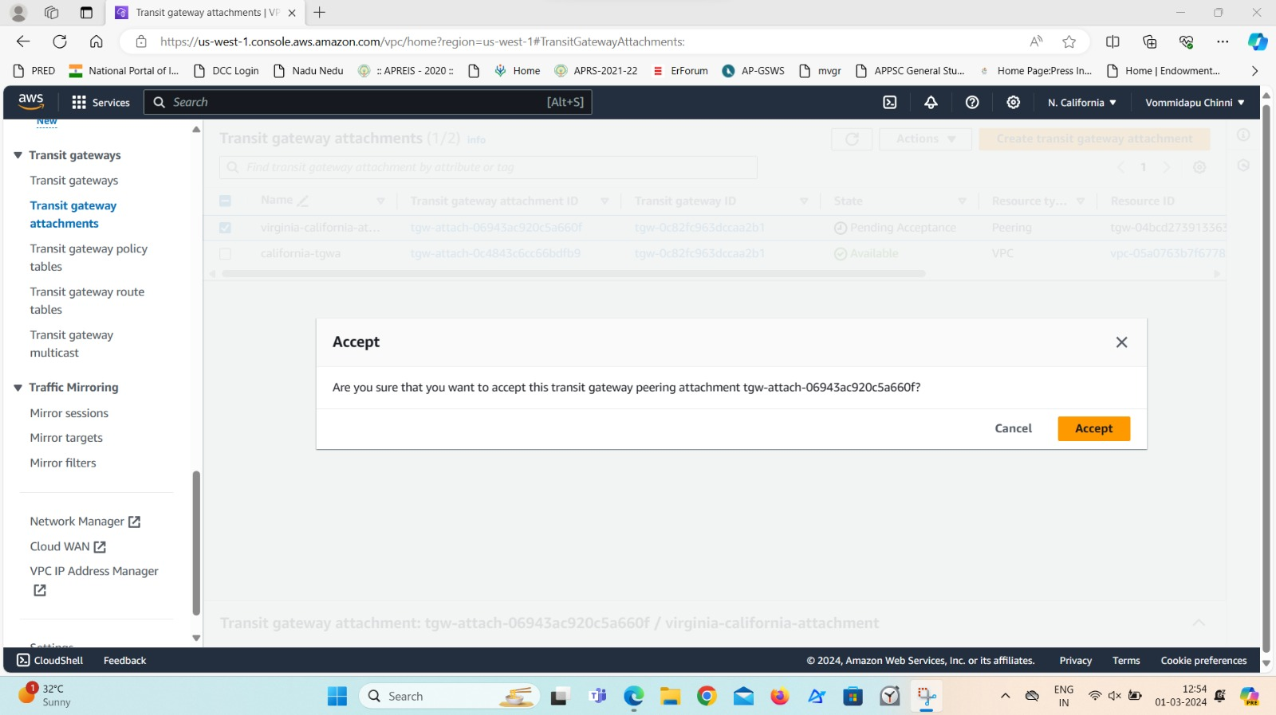

**Step 15:** The attachment can be seen as ‘available’ after some time.

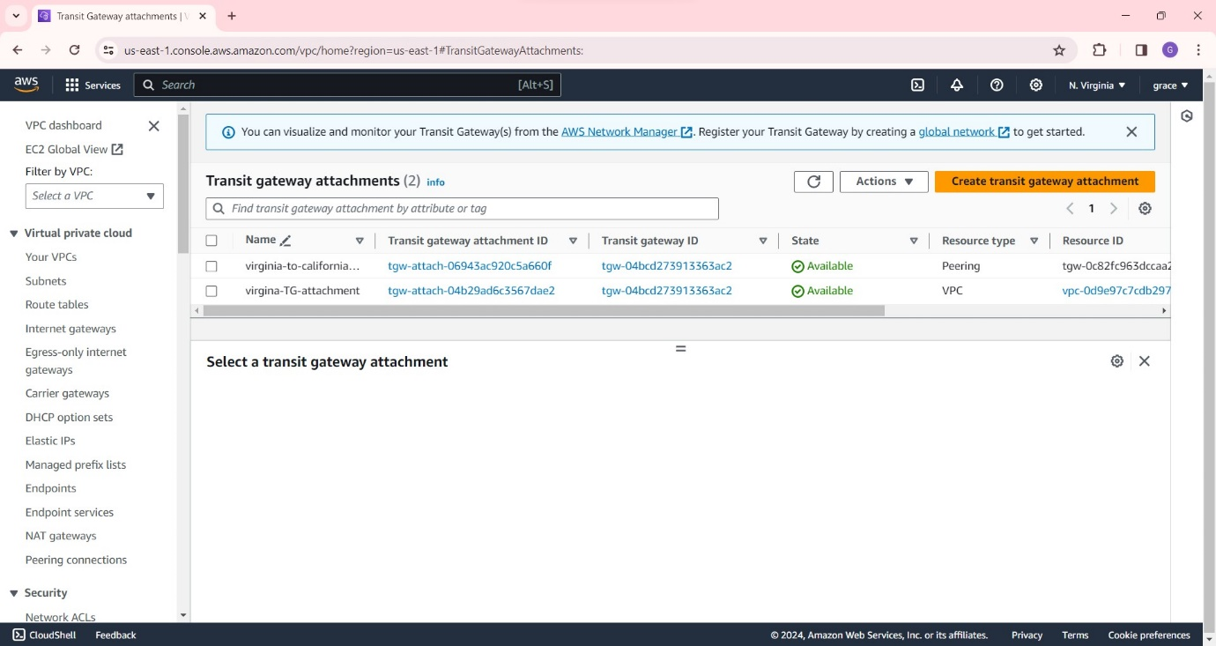

**Step 16:** Now go to transit gateway route tables and click on create static route and select the virginia to California attachment as shown below:

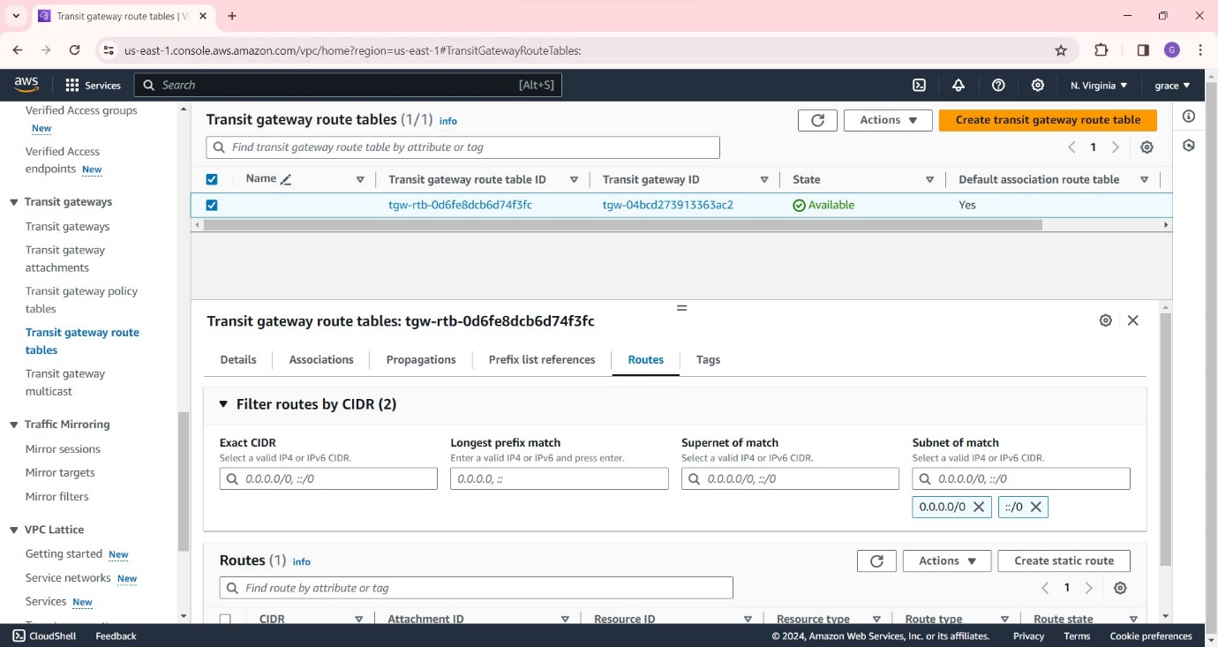

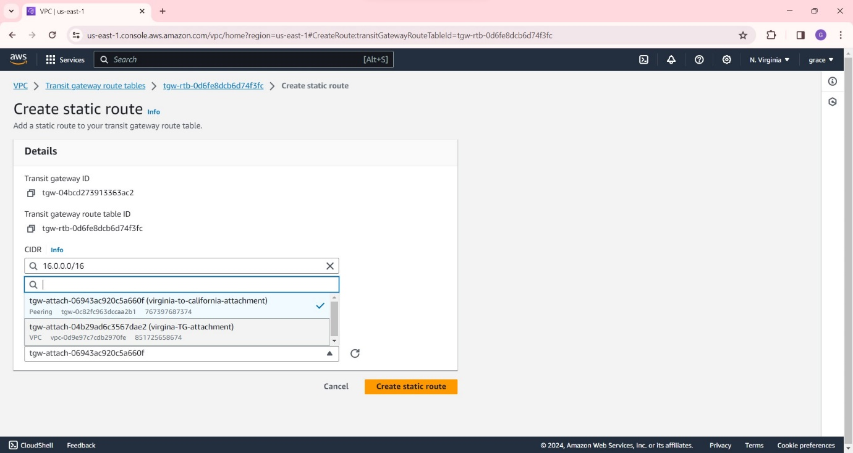

**Step 17:** Repeat the same in another account also.

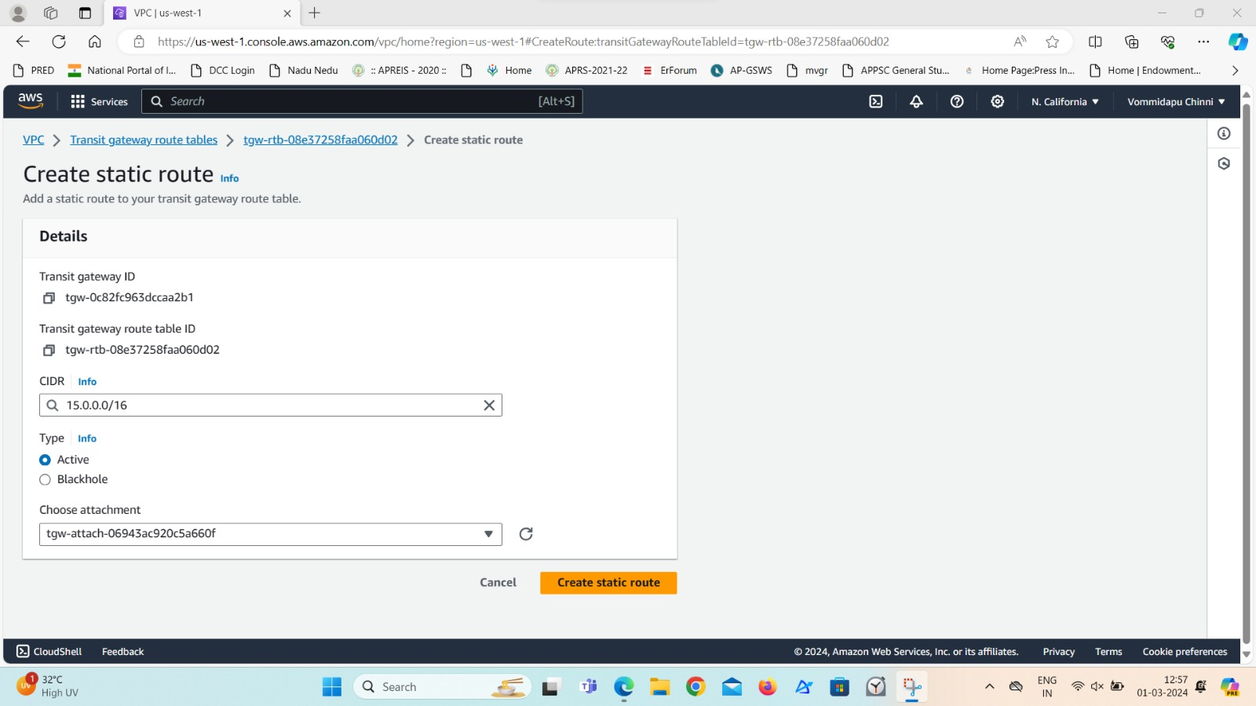

**Step 18:** Finally create two instances separately in both the accounts.

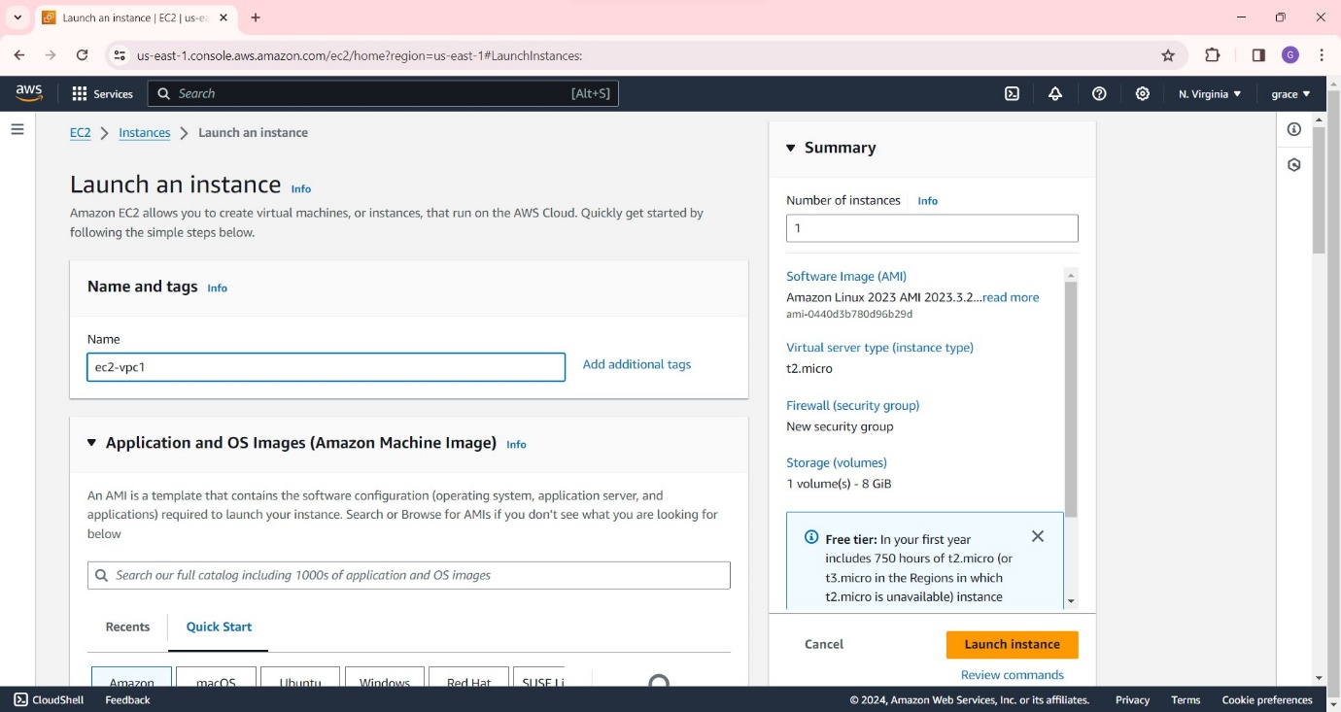 Add the security group as http and give the other account vpc cidr and click on launch instance.

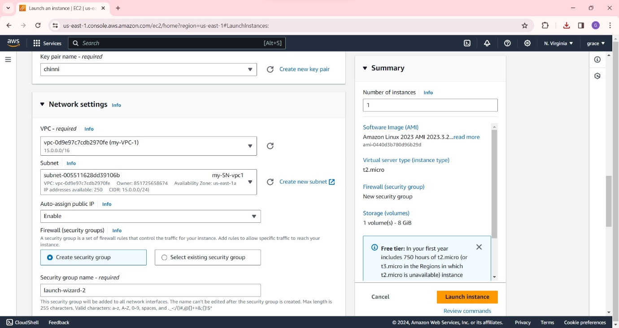

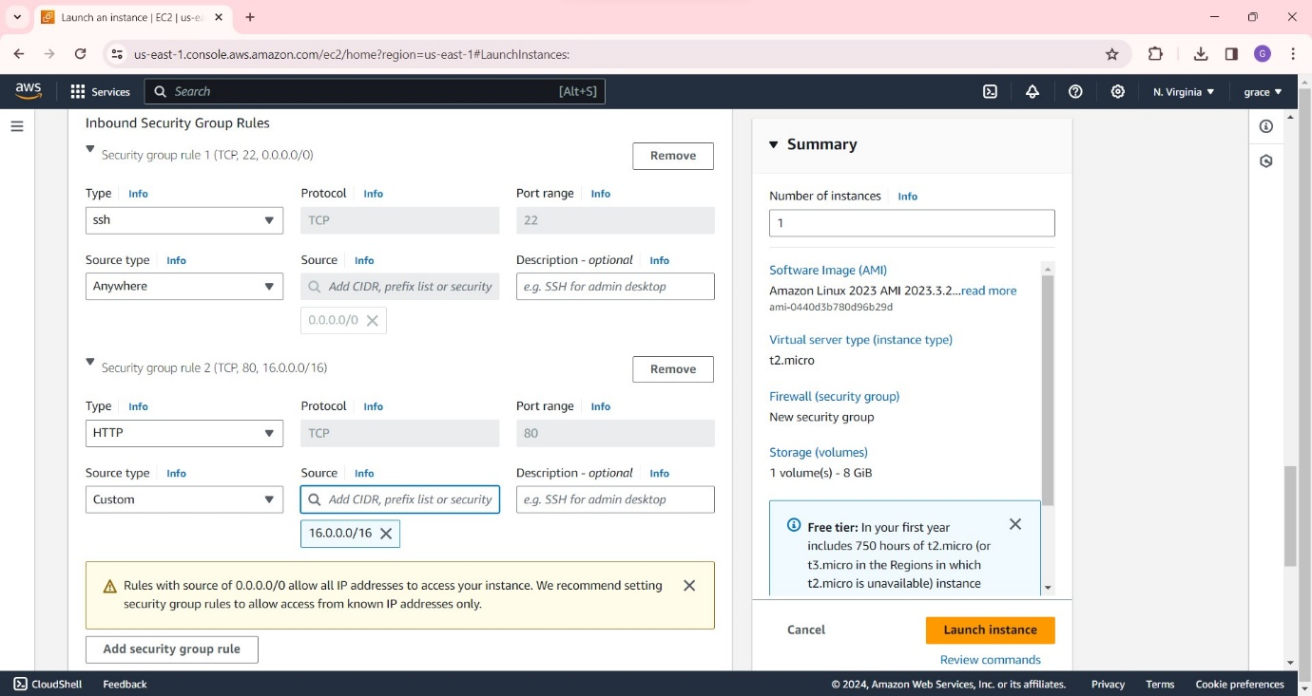

**Step 19:** Similarly in another account create instance.

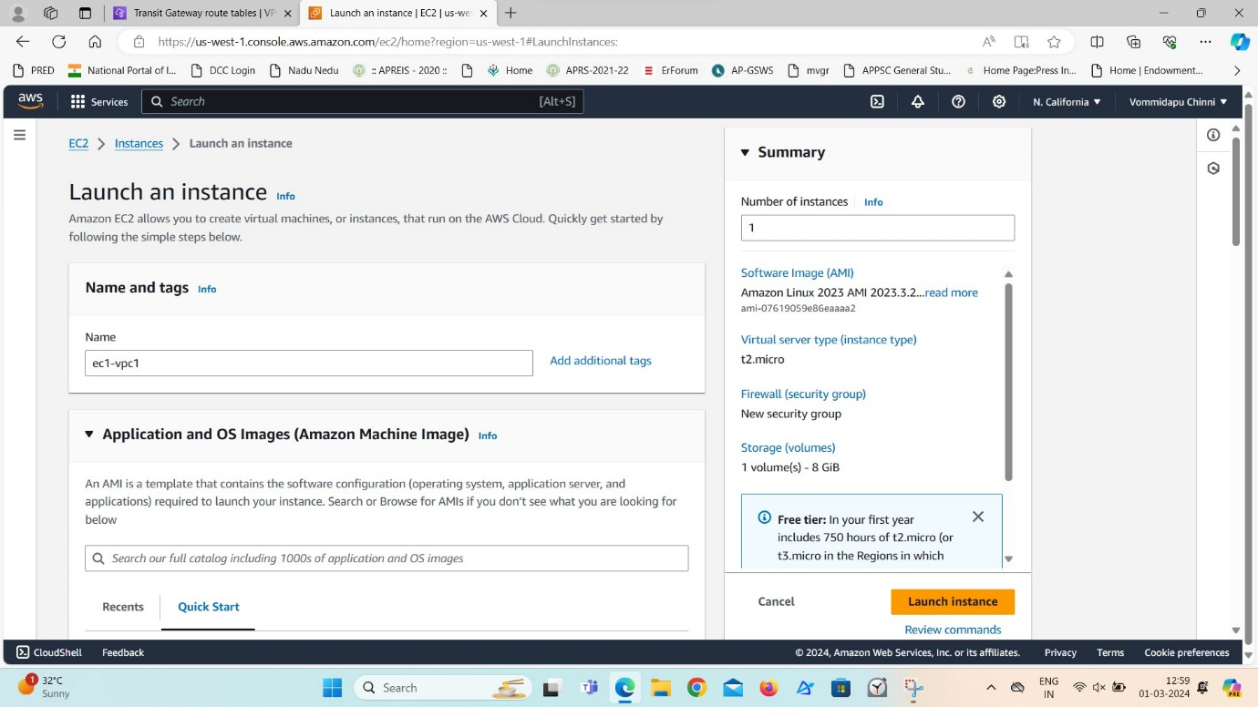

Select the particular default vpc and subnet .

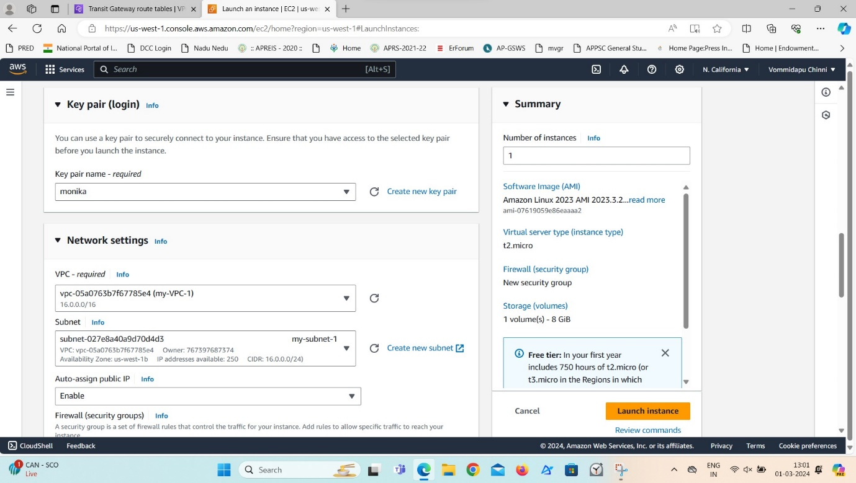

Also create security group rules as http and give the cidr of another account’s vpc as shown .

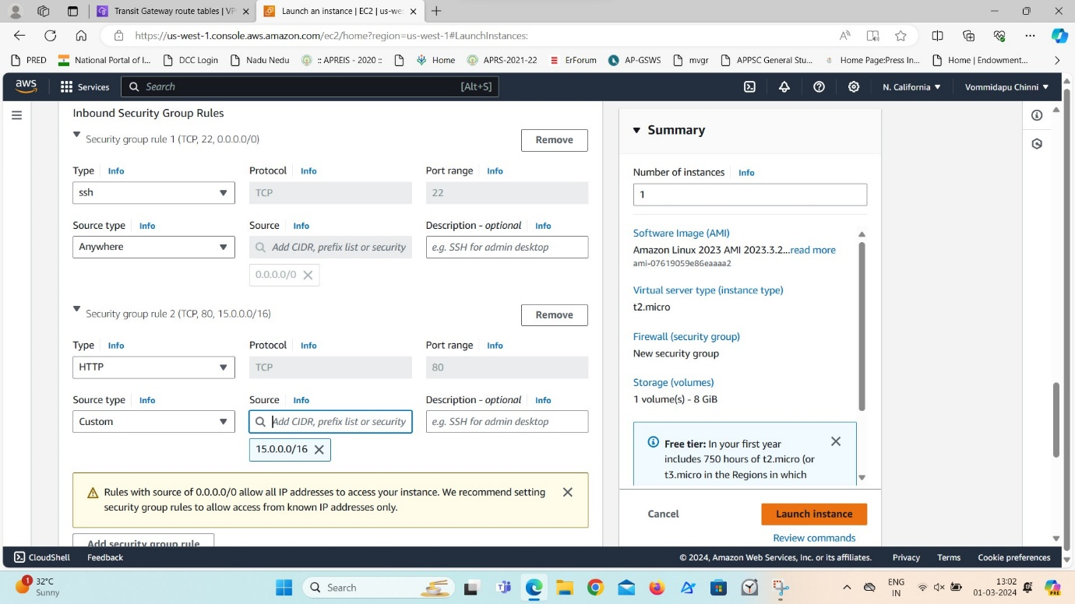

**Step 20:** Now connect the virginia instance and install nginx as follows.

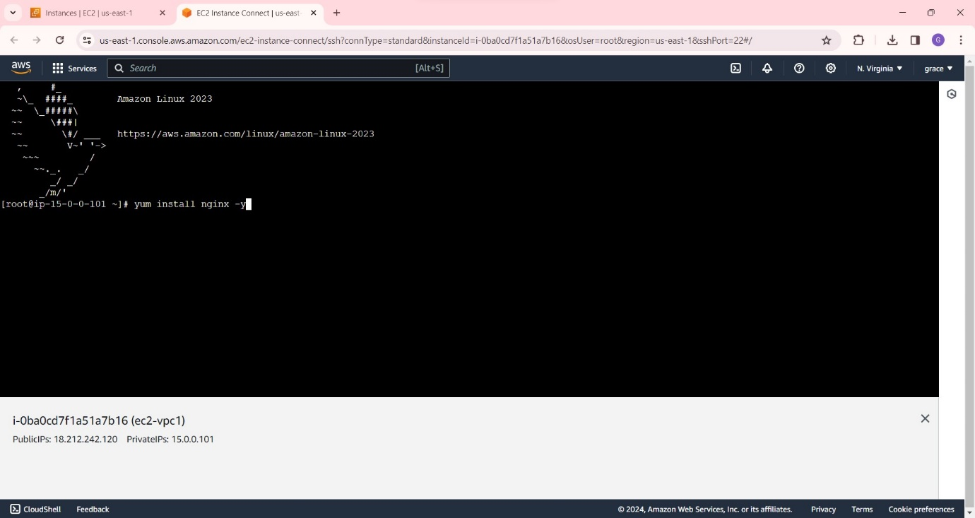follow the commands below and create a file and write there, ’I AM WEB SERVER 1’ and save it.

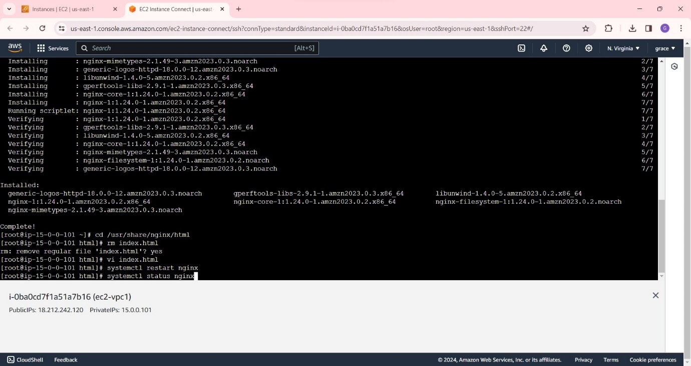

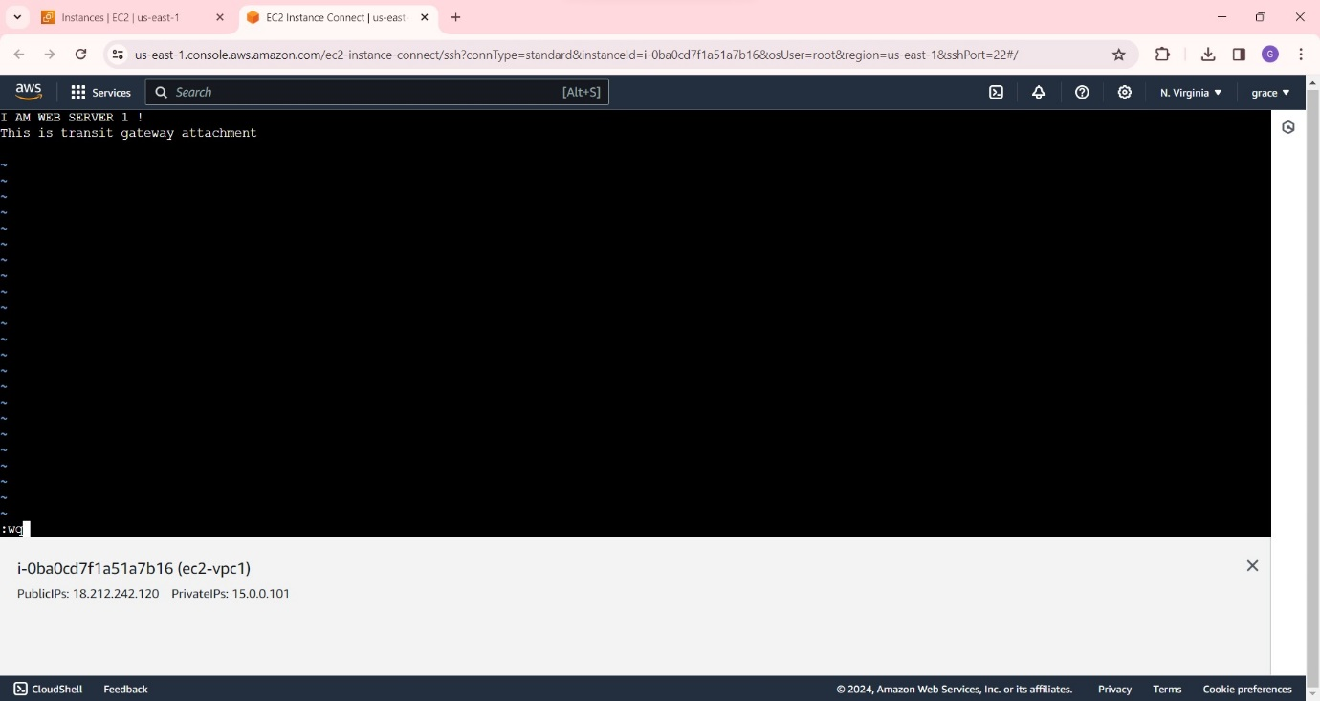

And check the file using ‘curl private IP of the server’

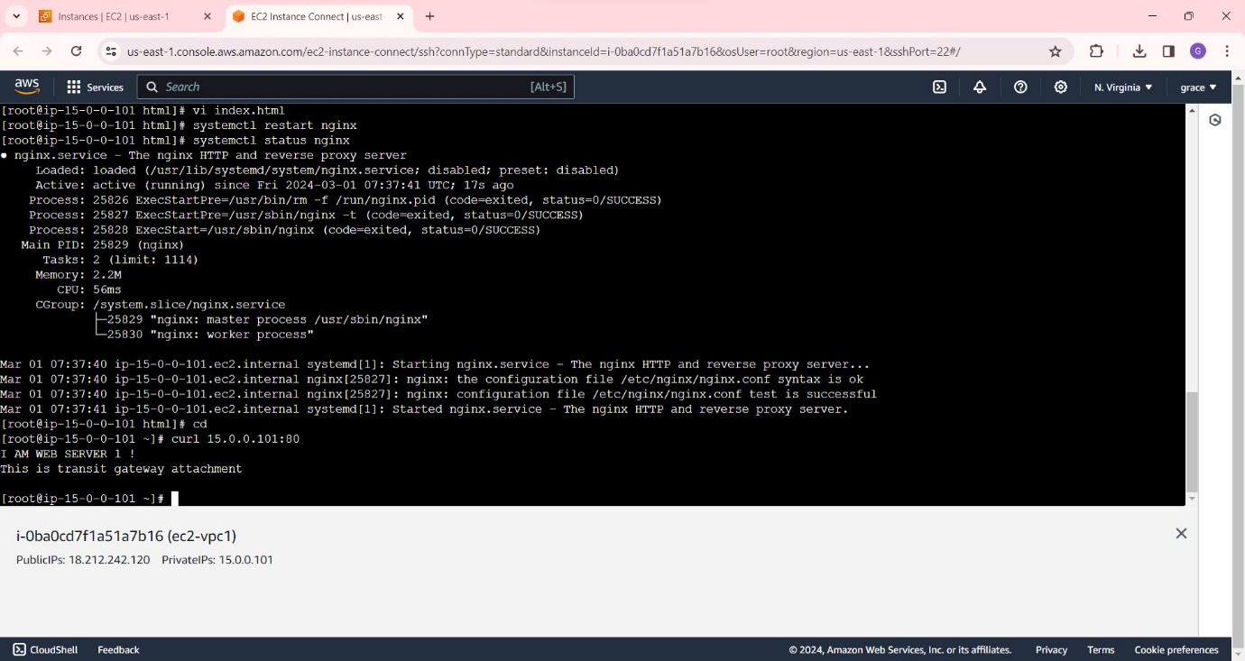

**Step 21:** And after checking the server with curl command at another account, it is clearly showing the file from another account.